**Setting Up the Board:**

* I have a two-dimensional array that stores strings for each single piece on the board.
* There is a Board method that has two for loops to go through both rows and columns and then checks through each placement in the Lab01.b.chess file provided and then adds it into the chessboard array through the AddPlacement method.

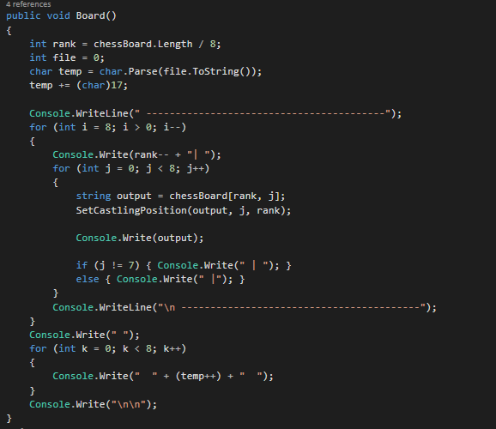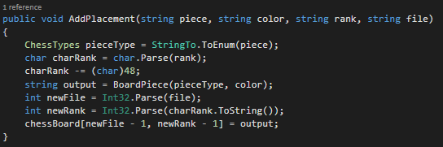

**Watching Movement:**

* I created a class specifically for checking for movement to separate movement from castling in two different methods.

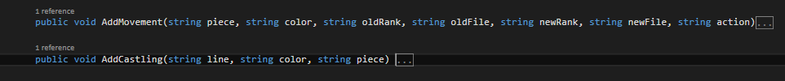

* In movement takes in each specific piece with location and its action and then changes the movement based off that action along with the legality of such.
* For castling, I have a few methods that check for different things for either king or queen side of the board and then whatever color.

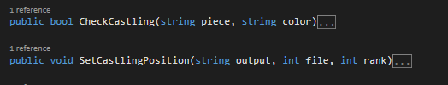

* + - Within CheckCastling, which is called in AddCastling, this is my main Boolean method that checks if either the King piece on each side has moved as well as the Rooks.
    - Within SetCastlingPosition, which is called in my Board method, it records each position at the beginning of the game of Kings and Rooks.